

Course Number | ELE 754
Course Title | Power Electronics
Semester/Year | F 2025
Instructor | Dr. David Xu

Lab Report No. | 1

Report Title | DC-DC Converter and DC Motor Drive

Section No. | 2
Submission Date | 10/25/2025
Due Date | 10/26/2025

Student Name | Student ID | Signature*
Connor Heikoop | 501114584
Shai Mourad | 501170415

(Note: remove the first 4 digits from your student ID)

*By signing above you attest that you have contributed to this submission and confirm that all work you have contributed to this submission is your own work. Any suspicion of copying or plagiarism in this work will result in an investigation of Academic Misconduct and may result in a “0” on the work, an “F” in the course, or possibly more severe penalties, as well as a Disciplinary Notice on your academic record under the Student Code of Academic Conduct, which can be found online at: http://www.ryerson.ca/content/dam/senate/policies/pol60.pdf

Table of Contents:
- Abstract…..……………………………………………………………………………………… 2
- Introduction………………………………………………………………………………….……2
- Theory……………………………………………………………………………………………..3
- Experiments..……………………………………………………………………………………. 6
- Conclusions & Recommendations……………………………………………………………13
- References……………………………………………………………………………………...13

Abstract
This laboratory experiment explores the performance evaluation aspect of DC-DC buck converters and DC motor drive systems with chopper control circuits. The project aims to determine the voltage conversion ratio for a buck converter with varying duty cycles and switching frequencies, in addition to the system’s performance evaluation with pulse width modulation ( pulses width moderation) control of PWM with DC motor drives. The configuration for conducting the in-lab test includes the use of the LabVolt Power Converter Supply Units, in addition to an LC filter with a permanent magnet DC motor. There is evaluation for the output voltage, ripple voltage, and inductor currents with respect to different operating systems in terms of Discontinuous Current Mode (DCM) and Continuous Current Mode (CCM). The outcome demonstrated that the voltage conversion ratio for a buck converter increases with an increase in the duty cycle ratio, in addition to the manner in which the ripple voltage is reduced with an increase in the SW frequencies for the system used. Taking into consideration the other part from the activation system for a permanent magnet motor with PWM control, it is apparent that the motor speed increases with an increase in the duty cycle, validating the viability for PWM control for efficiency in systems operation.
Introduction
There is an increasing need for efficient power conversion technology with the advent of renewable power sources, electric vehicles, as well as automation in the industrial sector. DC-DC converters play an integral role in voltage level conversion to meet specific system requirements with little loss of power. Among the different topologies designed for such conversion, the buck conversion topology is employed for stepping down DC voltage with high efficiency levels coupled with excellent control capabilities. Additionally, the technology employed in DC motor drives is the core of variable-speed drives.

The project entails the observation and recording of the performance of a buck converter and a DC drive using PWM control methods. The project comprises three significant phases: the buck converter in open- and closed-loop operation, the observation of the performance of a one-quadrant DC chopper motor driver interfaced with a DC motor, and the operation of a half-bridge DC-DC converter. By conducting the project, it is possible to gain insight into the proportional and disproportionate relationships between the duty cycle, output voltage, and motor speed in power electronic systems. The project helps to establish understanding in the principles of switches in converters, control systems, and their applications in motor control systems by using theoretical values obtained from system efficiency, dynamic performance, and CCM/DCM operation.
Theory
DC-DC converters and DC motor drives are extensively used in power electronic systems. Their main applications are for efficiency control and to convert electrical energy with varying voltage and current supplied to the load or motor. This section presents the theoretical background on buck converters, closed loop control operations, DC motor drives, and half-bridge DC-DC converters.

Buck Converter (Step-Down Converter)
A buck converter is a DC-DC converter that steps down a higher input voltage to a lower one while maintaining the same polarity. The switching element alternates between ON and OFF according to the PWM signal.

At “ON”, the switch conducts, and current flows through the inductor and load. The inductor stores the energy as the current increases. At “OFF”, the switch opens, and the inductor releases all the stored energy through the freewheeling diode to the load, maintaining its current flow. The average output voltage of the buck converter is as follows:
$V_{o} = DV_{in}$ [1]
Where:
$D = \frac{t_{on}}{T_{s}}$ [2] and $T_{s} = \frac{1}{f_{s}}$ [3]
The ripple current and output voltage ($Δ$I_{L} and $Δ$V_{o}) are calculated by:
$ΔI_{L} = \frac{(V_{in }- V_{o})D}{f_{s}L}$ [4] and $ΔV_{o} = \frac{ΔI_{L}}{{8f}_{s}C}$ [5]

Where:
L = inductance
C = capacitance
f_{s} = switching frequency

When the inductor current falls to zero, the converter is in CCM mode. Otherwise, the converter operates in DCM mode. Increasing frequency or inductance can maintain CCM operation, whereas lowering them can result in a consistent DCM operation.

The efficiency of a buck converter will ideally be 100%, but practically switching and conduction reduce it slightly. Experimental observations and data confirm these concepts.

Closed Loop Control of Buck Converters
Practically, maintaining a stable output voltage of a converter under various load conditions requires a feedback control mechanism. This experiment has a PI controller (Proportional-Integral controller) which was used to regulate the output voltage to a constant value.

The control loop measures the output voltage and compares it to the original reference value. The PWM duty cycle is adjusted by the error signal being processed by the controller. K_{p} adjusts immediate error, while K_{i} eliminates the steady state error.

This method makes sure the converter maintains a stable output. The dynamic performance is determined by the proportional and the integral terms. Bad or incorrect tuning can lead to oscillation or instability, while the desired tuning results in a smooth and fast transient response.

DC Motor Drive (with Chopper Control)
A one-quadrant chopper is used to control speeds of a DC motor with PWM control. The armature voltage is calculated by:
$V_{a } = DV_{dc}$ [6]
Where:
V_{a} = armature voltage
V_{dc} = supply voltage

The motor speed “w” is:
$ω = \frac{V_{a} - I_{a}R_{a}}{K_{e}}$ [7]
Where:
I_{a} = armature current
R_{a} = armature resistance
K_{e} = back EMF constant (of motor)

Increasing the duty cycle increases the average V_{a}, which results in a higher rotation speed. A DCM or CCM operation depends on the load torque and inductance. Acceleration and deceleration times are adjusted to make sure there is no high inrush current and smooth operation continues.

This technique ensures that there is an efficient speed regulation with little losses, as the switching elements alternate between “ON” and “OFF” modes.

Half-Bridge DC-DC converter
This is another type of DC-DC converter with two active switches (Q1 and Q4). Each switch alternately conducts which produces a bidirectional voltage waveform. This configuration efficiently divides input voltage into two halves using a capacitive divider or midpoint connection.
The output voltage expression is:
$V_{o} = \frac{DV_{in}}{2}$ [8]
for a 50% duty cycle. The inductor and capacitor smooth the waveform so it is a steady DC voltage. The topology offers an improved voltage usage and reduced harmonic distortion compared to its single-switch counterparts.

This lab shows the half-bridge converter has similar relationships to the buck converter, since its output voltage was increasing proportionally to the duty cycle (D) and ripple voltage decreased with higher f_{s}. This dual-switch system also improved the waveform symmetry and reduced switching stress on each device.

Operating Modes/Ripple Behavior
Operating modes (CCM and DCM) are determined by the relationship between inductor current, load resistance, and switching frequency. Results from this experiment show that the higher switching frequencies (10kHz and 5kHz) are CCM and lower frequencies (2.5kHz) are DCM.

Ripple voltage and current inversely depend on switching frequency and directly on inductor current ripple, proven by the derived formulas. Accordingly, increasing f_{s} or C reduces the output ripple, which also improves stability and the efficiency of the converter.

Experiments
These are the results of the individual experiments that took place during this lab:
Part A:
This experiment uses the IGBT chopper/converter unit to control a RLC load using the lab equipment. Then, we use the buck converter option on the LVDAC-EMS option to control the switching for the circuit. Our goal is to monitor the output voltage and current for the circuit, as well as the operating mode of the circuit. We vary the duty cycle to see the change in results. We can see the results in Images 1-5.

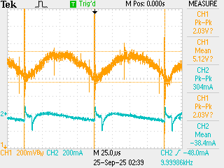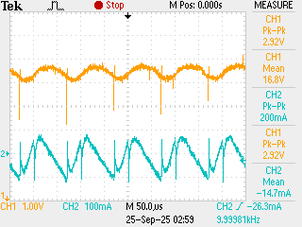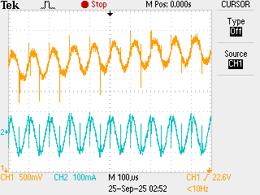
Image 1: Waveform for D=10% Image 2: Waveform for D=30% Image 3: Waveform for D=50%
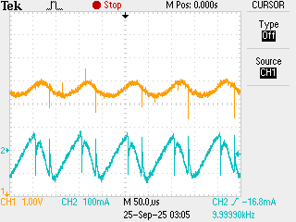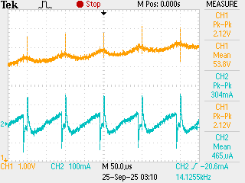
Image 4: Waveform for D=70% Image 5: Waveform for D=90%

Duty Cycle (%) |  | 10 | 30 | 50 | 70 | 90
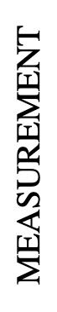 | V_{DC} (V) | 60 | 60 | 60 | 60 | 60
 | V_{o} (V) | 5.322 | 16.78 | 27.78 | 41.41 | 53.60
 | ∆V_{o} (V, p-p) | 0.352 | 0.7 | 0.8 | 0.8 | 0.64
 | ∆I_{L} (mA) | 80.3 | 200 | 212 | 220 | 112
 | Operating Mode | CCM | CCM | CCM | CCM | CCM
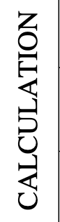 | V_{o} (V) | 6 | 18 | 30 | 42 | 54
 | ∆V_{o} (V, p-p)  = ∆I_{L}/8f_{s}C | 0.675 | 1.575 | 1.875 | 1.575 | 0.675
 | ∆I_{L} (A)  =(V_{DC​}−V_{o}​)⋅D⋅T_{s}​​/L | 0.27 | 0.63 | 0.75 | 0.63 | 0.27
Table A: Results of Buck Converter (10 kHz f_{sw})

Example Calculations:
$V_{O}=DV_{DC} = (0.{1)(60) = 6 V}_{}$

$∆V_{O}= \frac{∆I_{L}}{8f_{s}C}=\frac{(0.08)}{8(10k)(5uF)}=0.675 V$

$∆I_{L}= \frac{(V_{DC}-V_{O})DT_{S}}{L}=\frac{(60-6)(0.1)(0.0001)}{(2m)}=0.27 mA$

The next step was to redo the experiment but with a switching frequency of 2.5 kHz. These results can be seen in Table B. The waveform results can be seen in Image 6-10.

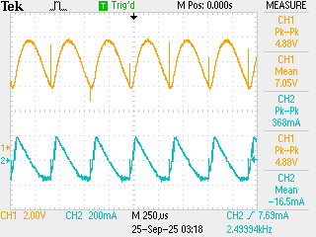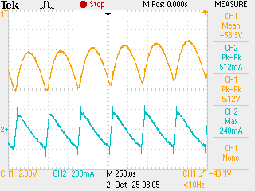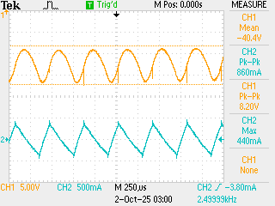
Image 6: Waveform for D=10% Image 7: Waveform for D=30% Image 8: Waveform for D=50%

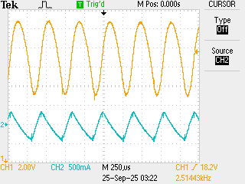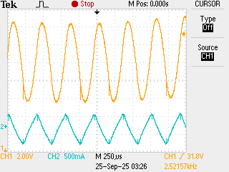
Image 9: Waveform for D=70% Image 10: Waveform for D=90%

Duty Cycle (%) |  | 10 | 30 | 50 | 70 | 90
 | V_{DC} (V) | 60 | 60 | 60 | 60 | 60
 | V_{o} (V) | 6.69 | 17.87 | 29.34 | 41.68 | 53.60
 | ∆V_{o} (V, p-p) | 4.16 | 8.0 | 8.96 | 9.00 | 4.32
 | ∆I_{L} (mA) | 368 | 820 | 860 | 880 | 504
 | Operating Mode | DCM | DCM | DCM | DCM | DCM
 | V_{o} (V) | 6 | 18 | 30 | 42 | 54
 | ∆V_{o} (V, p-p) | 10.8 | 25.2 | 30 | 25.2 | 10.8
 | ∆I_{L} (A) | 1.08 | 2.52 | 3 | 2.52 | 1.08
Table B: Results of Buck Converter (2.5 kHz f_{sw})

Example calculations can be seen after Table A.

The next experiment uses the same buck converter, but this time uses the feedback bank of the lab equipment. This regulates the voltage to 50% of the input voltage. This means that the equivalent duty cycle will be 0.5. We vary the load resistance for different values. The waveform results can be seen in Images 11-16. The numerical results can be seen in Table C.

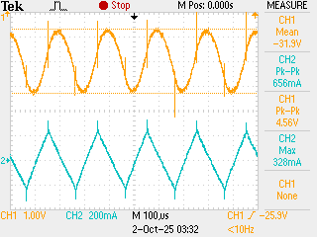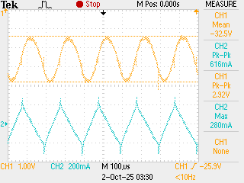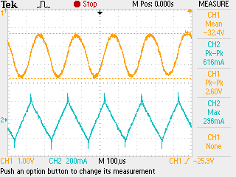
Image 11: Waveform for R=30 Ω Image 12: Waveform for R=40 Ω Image 13: Waveform for R=60 Ω

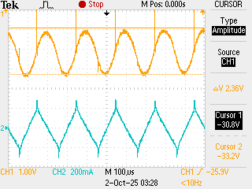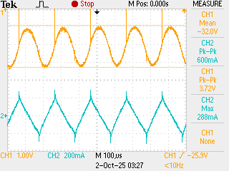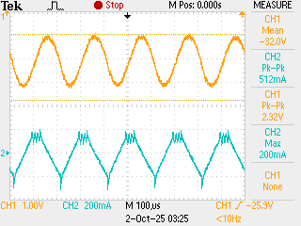
Image 14: Waveform for R=80 Ω Image 15: Waveform for R=120 Ω Image 16: Waveform for R=240 Ω

Load Resistance (ohms) |  | 240 | 120 | 80 | 60 | 40 | 30
 | V_{DC} (V) | 60 | 60 | 60 | 60 | 60 | 60
 | V_{o} (V) | 32.57 | 32.61 | 32.66 | 32.71 | 32.69 | 32.82
 | ∆V_{o} (V, p-p) | 2.32 | 2.36 | 2.36 | 2.44 | 2.40 | 2.60
 | ∆I_{L} (mA) | 512 | 600 | 592 | 616 | 616 | 656
 | Operating Mode | CCM | CCM | CCM | CCM | CCM o | CCM
 | Voltage Ratio (V) | 30 | 30 | 30 | 30 | 30 | 30
 | ∆V_{o} (V, p-p) | 7.5 | 7.5 | 7.5 | 7.5 | 7.5 | 7.5
 | ∆I_{L} (mA) | 1.5 | 1.5 | 1.5 | 1.5 | 1.5 | 1.5
Table C: Results of Buck Converter (5 kHz f_{sw}) with feedback

Example calculations can be seen after Table A.

Part B:
This experiment uses a one-quarter chopper with a DC motor to monitor the same values as Part A. We vary the duty cycle to achieve different output voltages and current. For this experiment, we have to change the acceleration and deceleration time to 10 seconds so that we do not provide too much inrush current for the DC motor. Waveform results can be seen in Image 17-21.

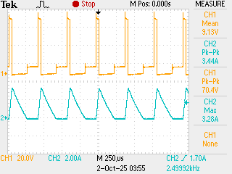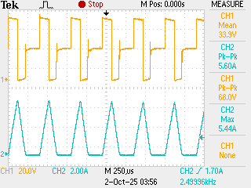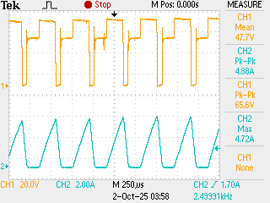
Image 17: Waveform for D=10% Image 18: Waveform for D=30% Image 19: Waveform for D=50%

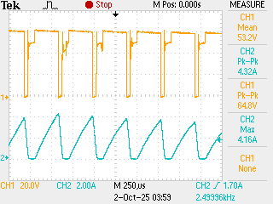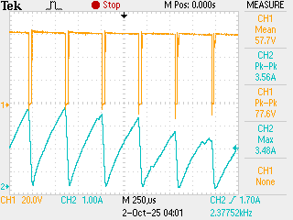
Image 20: Waveform for D=70% Image 21: Waveform for D=90%

Duty Cycle (%) |  | 10 | 30 | 50 | 70 | 90
 | V_{DC} (V) | 60 | 60 | 60 | 60 | 60
 | V_{o} (V) | 7.76 | 31.54 | 44.83 | 50.83
 | ∆V_{o} (V, p-p) | 70.4 | 68.0 | 65.6 | 64.8 | 77.6
 | ∆I_{L} (A) | 3.28 | 5.44 | 4.72 | 4.16 | 3.48
 | Operating Mode | DCM | DCM | DCM | DCM | DCM
 | Speed (RPM) | 389 | 1430 | 1901 | 2121 | 2233
Table D: Results of One-Quadrant Chopper (2.5 kHz f_{sw}) with feedback

Part C:
This experiment uses the IGBT chopper/converter unit to control a RLC load using the lab equipment. Then, we use the half bridge DC/DC converter option on the LVDAC-EMS option to control the switching for the circuit. Our goal is to monitor the output voltage and current for the circuit, as well as the operating mode of the circuit. We vary the duty cycle to see the change in results. The waveform results can be seen in Images 22-26.

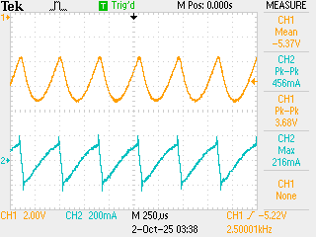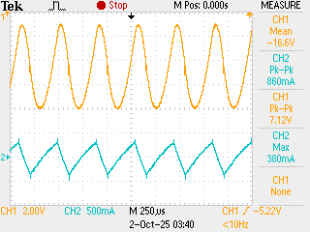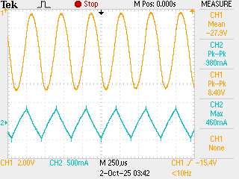
Image 22: Waveform for D=10% Image 23: Waveform for D=30% Image 24: Waveform for D=50%

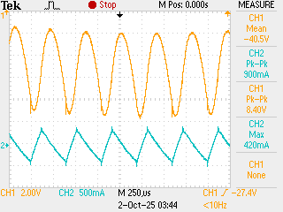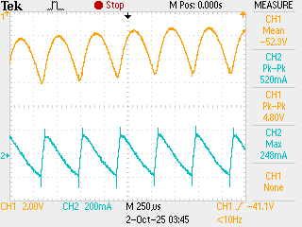
Image 25: Waveform for D=70% Image 26: Waveform for D=90%
Duty Cycle (%) |  | 10 | 30 | 50 | 70 | 90
 | V_{DC} (V) | 60 | 60 | 60 | 60 | 60
 | V_{o} (V) | 5.56 | 17.35 | 28.53 | 41.00 | 53.70
 | ∆V_{o} (V, p-p) | 3.68 | 7.12 | 8.40 | 8.40 | 4.80
 | ∆I_{L} (mA) | 472 | 860 | 980 | 900 | 520
 | V_{o} (V) | 6 | 18 | 30 | 42 | 54
 | ∆V_{o} (V, p-p)  = ∆I_{L}/8f_{s}C | 10.8 | 25.2 | 30 | 25.2 | 10.8
 | ∆I_{L} (mA)  =(V_{DC​}−V_{o}​)⋅D⋅T_{s}​​/L | 1.08 | 2.52 | 3 | 2.52 | 1.08
Table D: Results of Half Bridge DC/DC Converter (2.5 kHz f_{sw}) with feedback

Conclusions and Recommendations
This experiment fully shows the use and functionality of DC/DC converters. It covers multiple options such as: buck converter, one-quadrant choppers, and half bridge DC/DC converters. The results for the calculation from Parts A and C differ from the experiment results a little, this could be due to false averages in the oscilloscope. Even if the results are not exactly accurate, the results of this lab properly showed the correlation between duty cycle and output voltage and current. Using each of these converters, we can see a parabolic relation in duty cycle and ripple voltage and current. This is due to the fact that increasing the duty cycle increases the difference in input and output voltage, causing lows in lower in higher voltages based on the equations shown in Part A. We can also see the higher the switching frequency, the lower the ripple voltage and current. This is due to the equation for ripple voltage having switching frequency in the denominator and ripple current having switching period in the numerator. We also see that lowering the switching frequency below 5 kHz switches the converters to DCM mode, rather than CCM. In conclusion, this lab was very successful in displaying the properties of the DC/DC converters.

Recommendations:
- Get familiar with lab equipment before beginning the experiment.
- Try to not use the average function on the oscilloscope, as it could be inaccurate.
- Do calculations before the lab so that we can compare values with the lab results.
- Use a multimeter for accurate voltage reading instead of the oscilloscope.

References

References
Toronto Metropolitan University. (n.d.). Project 1 DC-DC Converter and DC Motor Drive [PDF]. D2L. https://courses.torontomu.ca/d2l/le/content/1064952/viewContent/6644427/View
Toronto Metropolitan University. (n.d.). Project Writing Guide [PDF]. D2L. https://courses.torontomu.ca/d2l/le/content/1064952/viewContent/6668709/View

